**Sending Email Reports:**

Install the plugin “Email Extension”

Now go to Manage Jenkins and go to “Configure System”.

Here you will see a new setting “Extended E-mail Notification” added.

Enter the settings as follows. (Enter your own email id and password and save it).

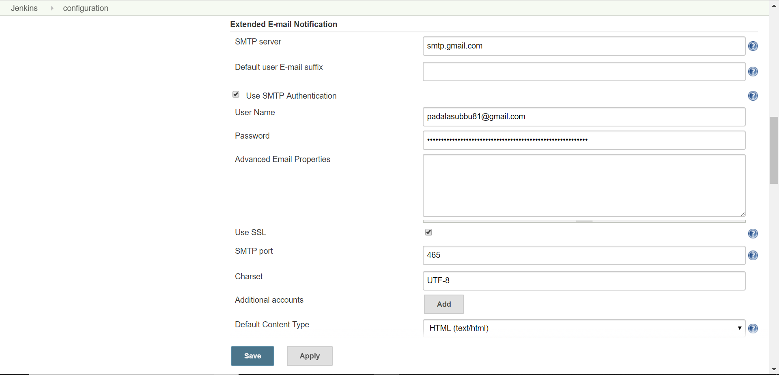

Now go to the project configuration and click on “Add Post-Build action” and you will see “Editable Email Notification”. Click on advanced settings and Add the following settings.

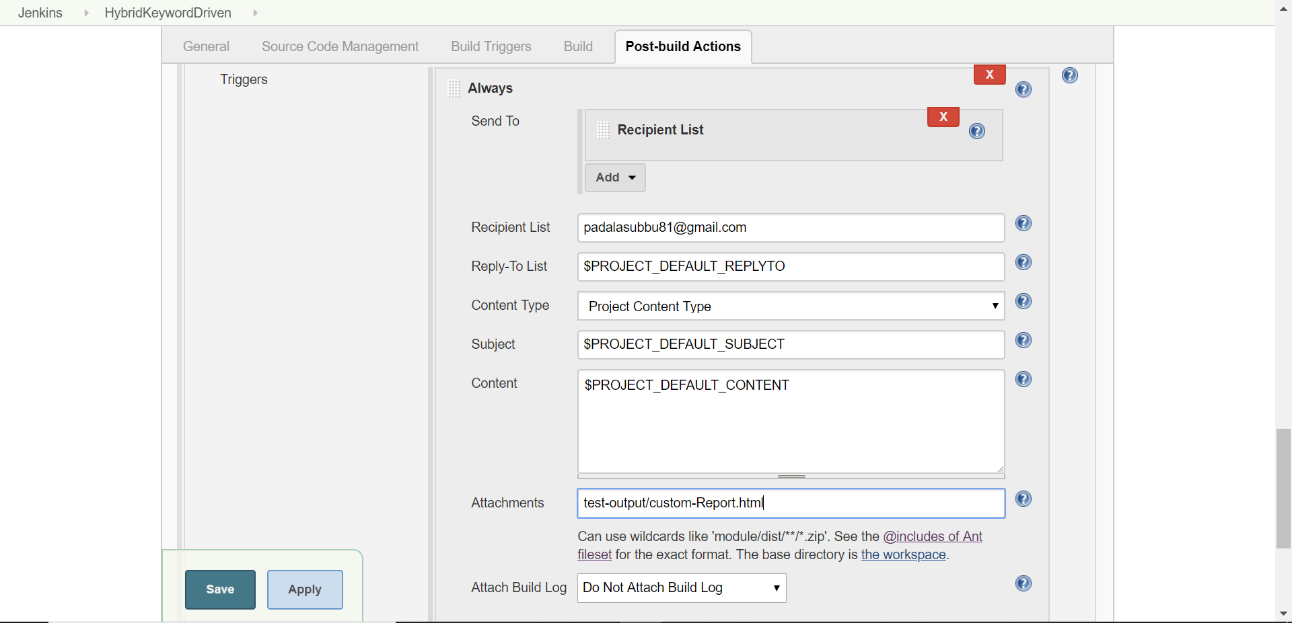

Since we are using gmail, we need to make some changes to gmail settings to use gmail SMPT server. The following are the changes.

1. Enable IMAP in your gmail settings.

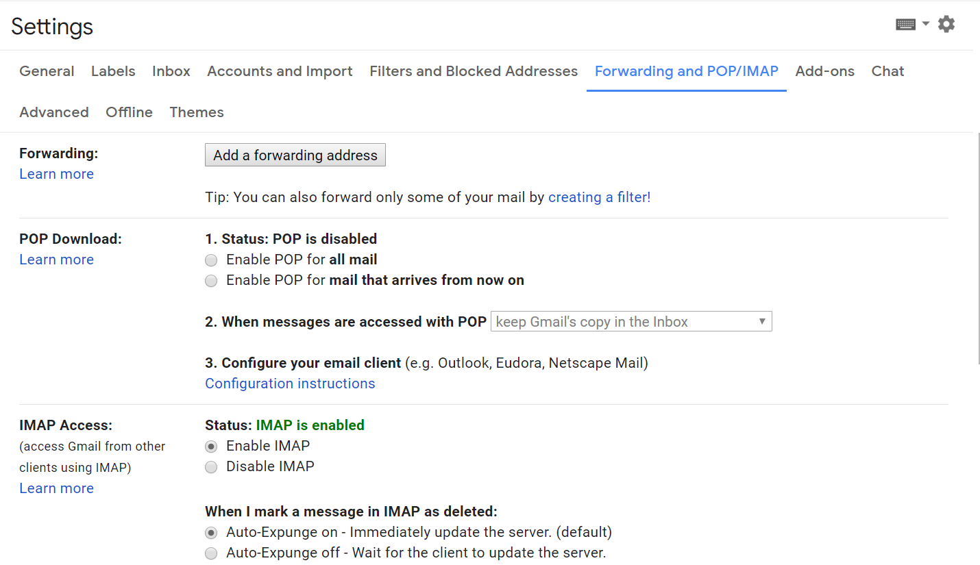

2. Allow Less secure apps for the gmail account you are using.

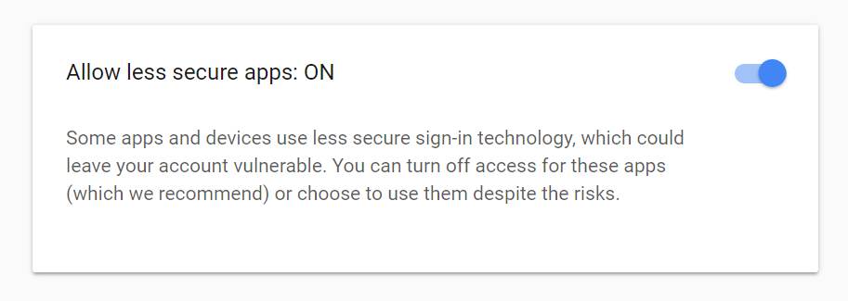

You can do it by going to your google account and going to **Sign-in & security** tab.

Now run the test and the email should be sent now.

